Module Name: Dynamic Controls
Test Case ID: 183
Webpage URL: “https://the-internet.herokuapp.com/ ”

● Scenario ID: 13a
Scenario: Add and Remove Elements
Test Steps:
- Open PyCharm.
- Open your existing WelcomeScreen project.
- Open script1.py.
- Enter the Selenium code given below.
- Save the file.
- Run the Python program.
- Selenium opens Chrome and opens The Internet website.
- It opens Add/Remove Elements.
- It clicks Add Element.
- It verifies that the Delete button appears.
- It clicks Delete.
- It closes the browser.

Screenshots:
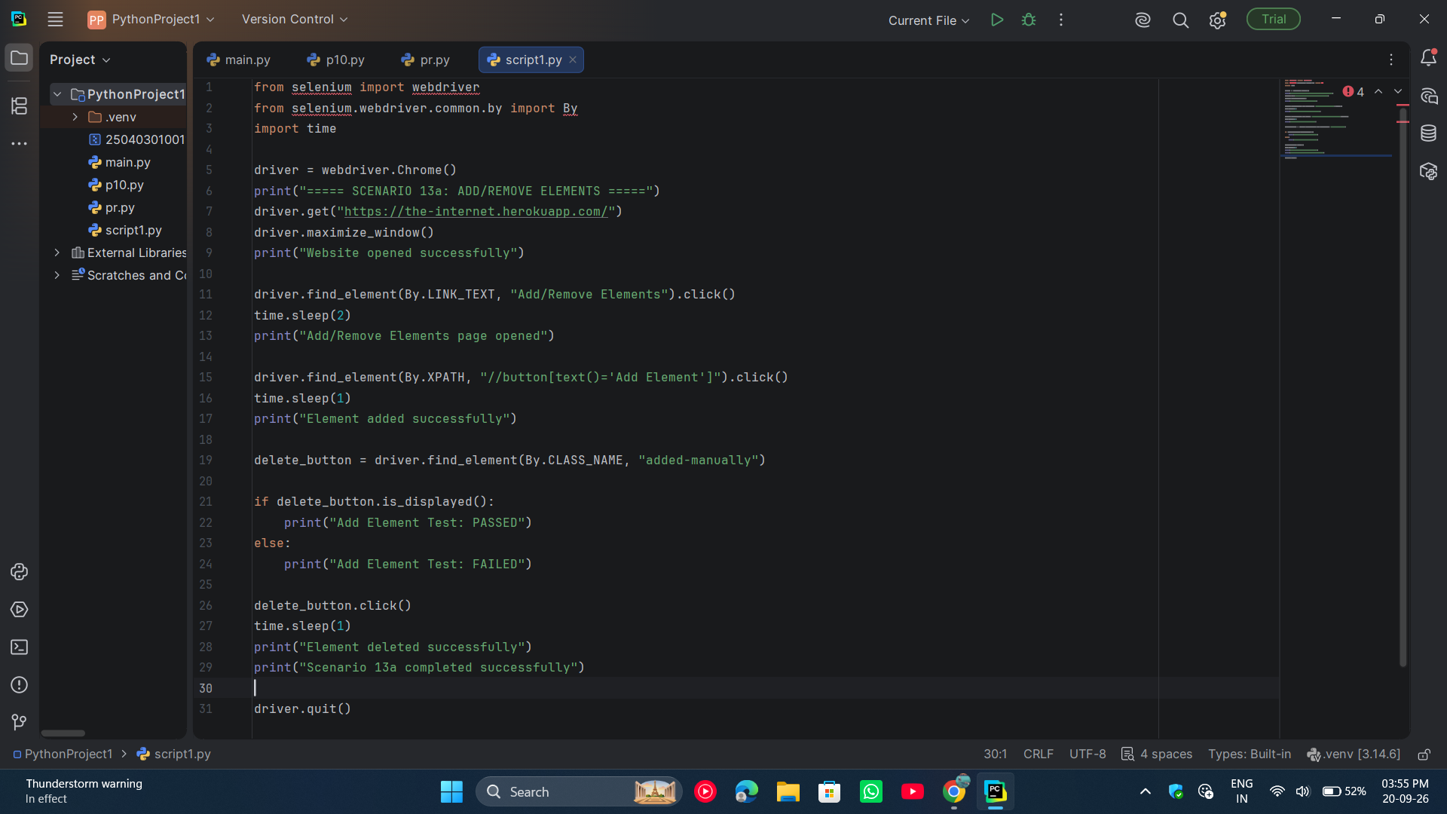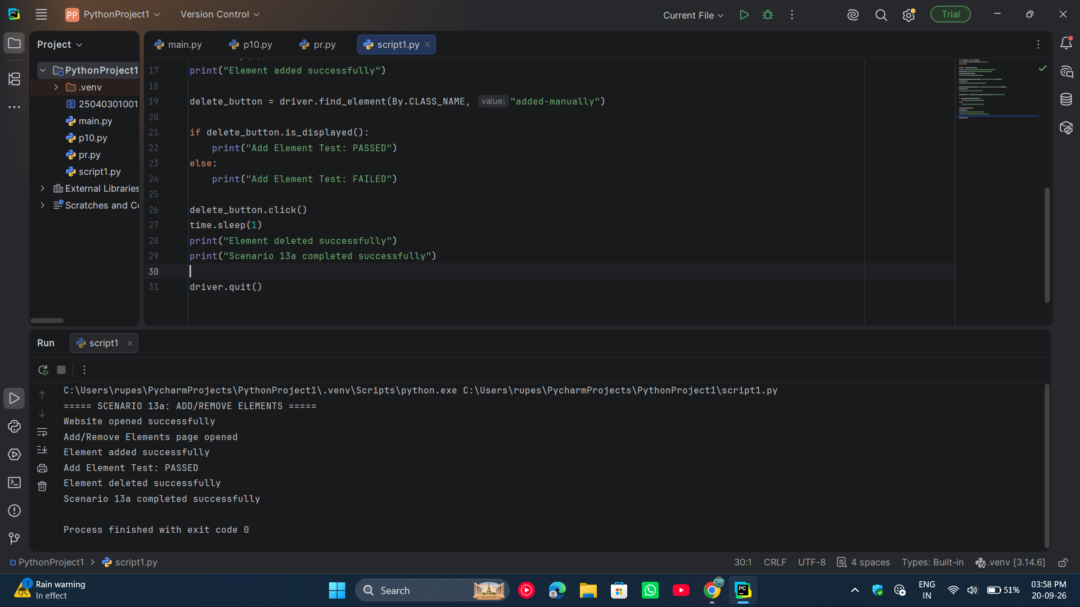

● Scenario ID: 13b
Scenario: JavaScript Alerts
Test Steps:
- Open PyCharm on the computer.
- Open the existing WelcomeScreen Selenium project.
- Open the script1.py Python file.
- Import the Selenium WebDriver and required Selenium modules.
- Create a Chrome WebDriver object.
- Open the URL: https://the-internet.herokuapp.com/javascript_alerts.
- Maximize the Chrome browser window.
- Click on “Click for JS Alert”.
- Wait for the JavaScript alert to appear.
- Switch Selenium control from the webpage to the alert.
- Read and display the alert message.
- Click OK on the alert using alert.accept().
- Verify the result message displayed on the webpage.
- Print “JavaScript Alert Test: PASSED” if the expected result is displayed.
- Close the browser using driver.quit().

Screenshots:
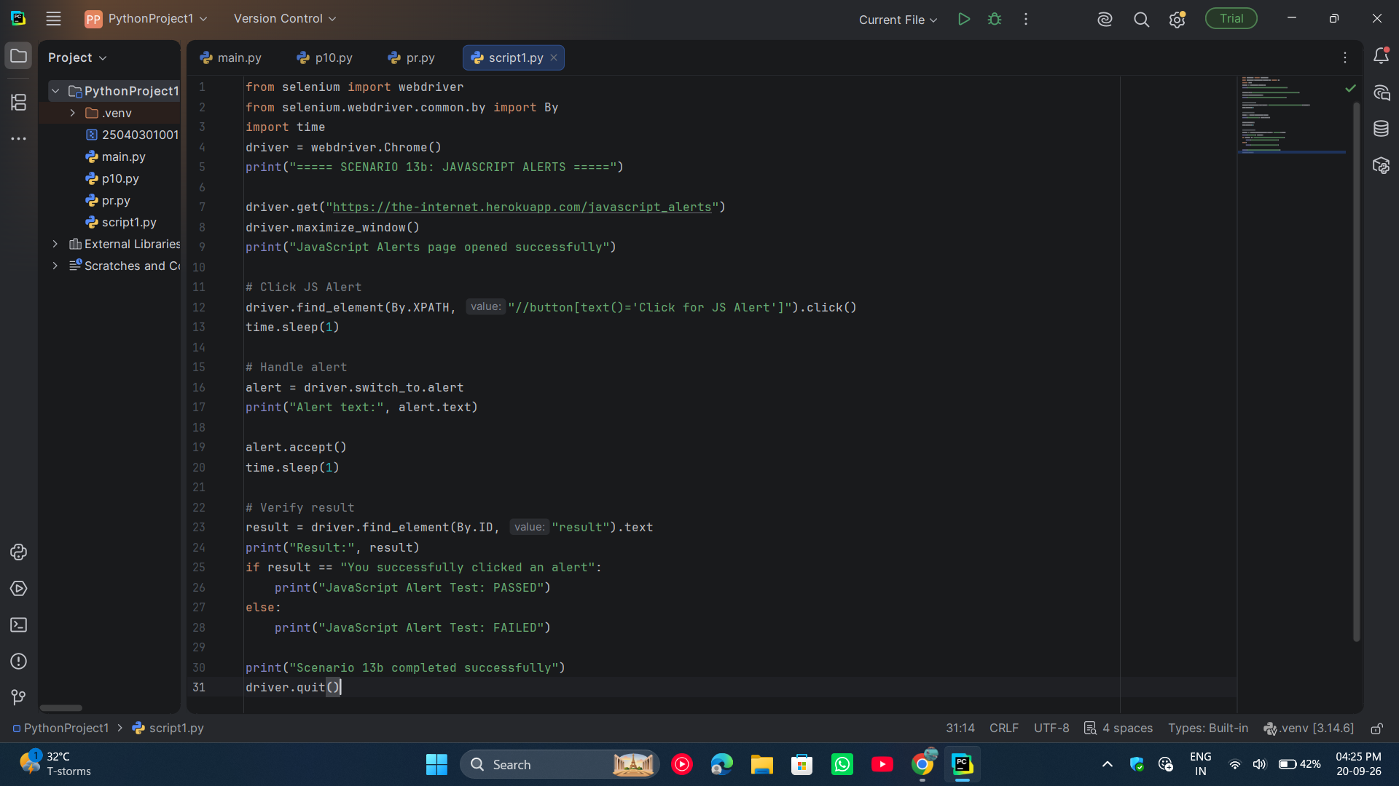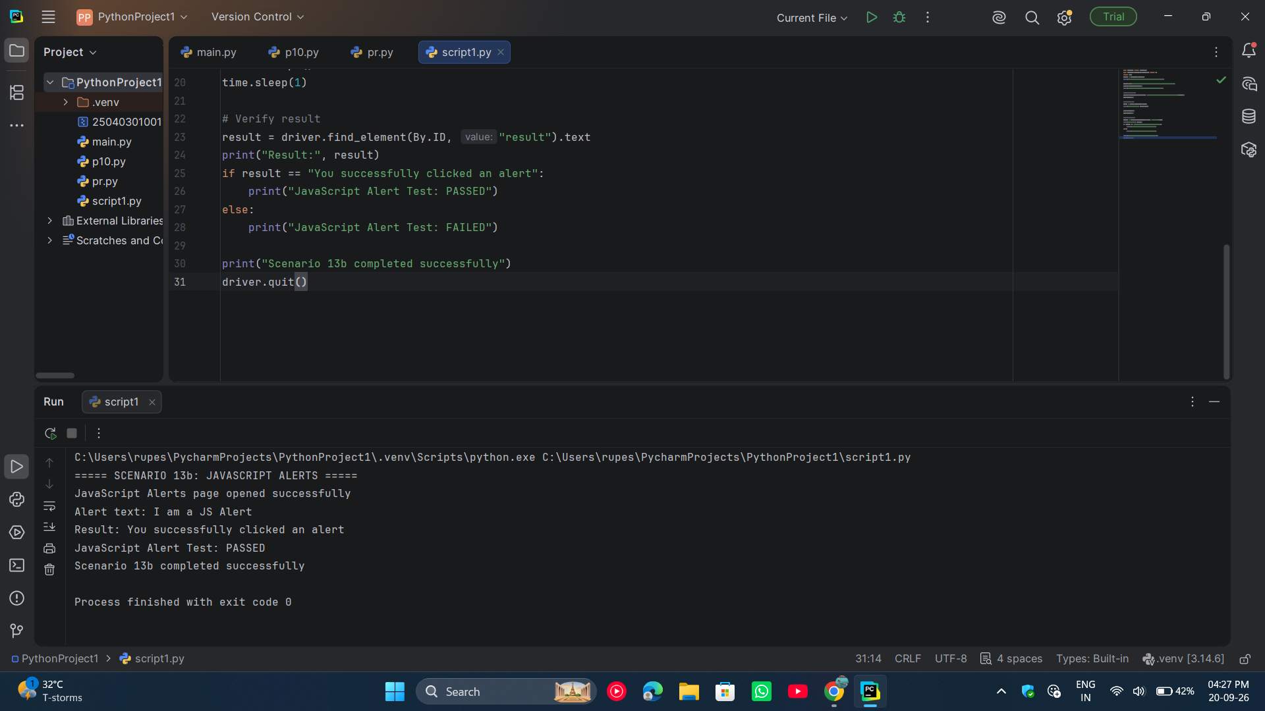

● Scenario ID: 13c
Scenario: Dynamic Controls
Test Steps:
- Open PyCharm.
- Open your Selenium project.
- Open script1.py.
- Enter the Dynamic Controls Selenium code.
- Save the file using Ctrl + S.
- Run the program.
- Chrome opens the Dynamic Controls page.
- Click Remove.
- Verify that the checkbox is removed and “It’s gone!” message appears.
- Click Add.
- Verify that the checkbox appears again.
- Check the PyCharm console for PASSED results.
- Close the browser.
Screenshots: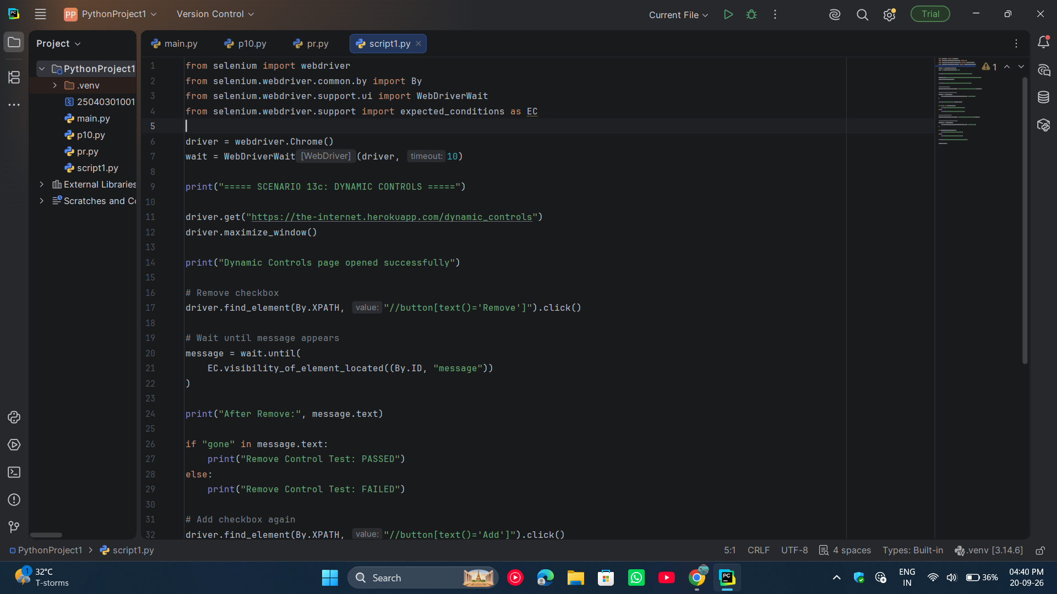

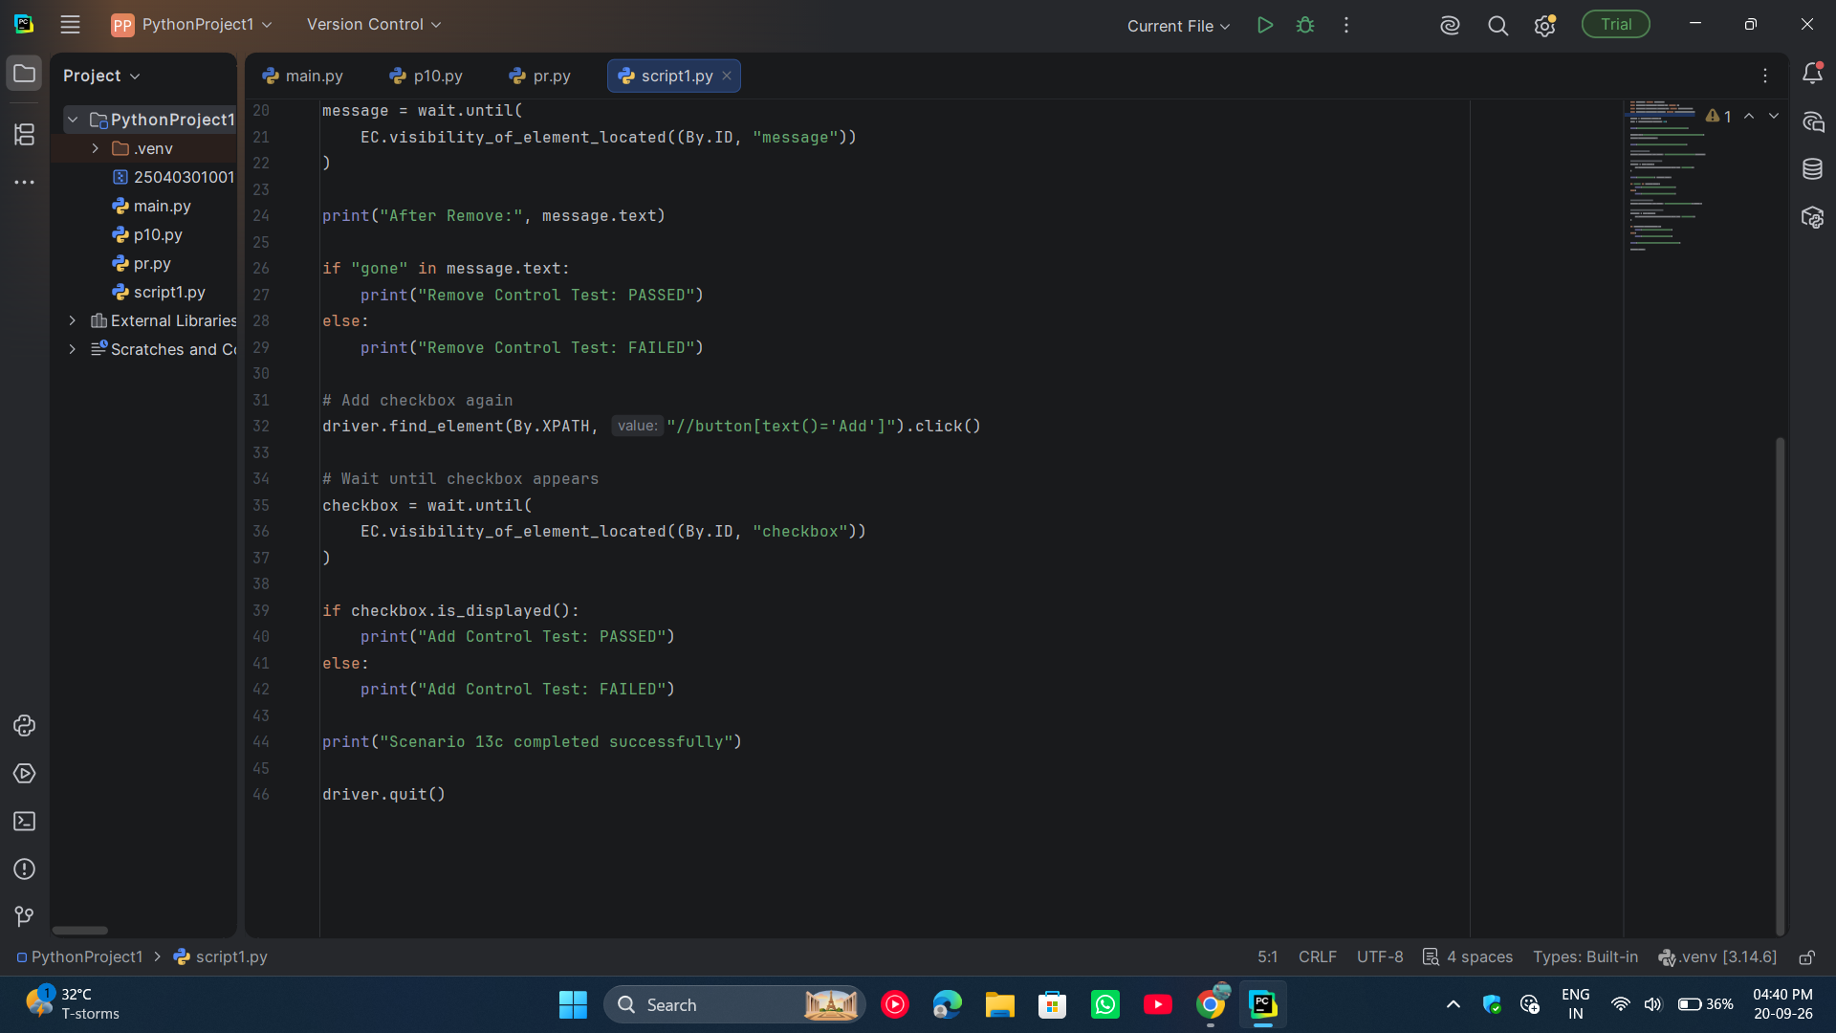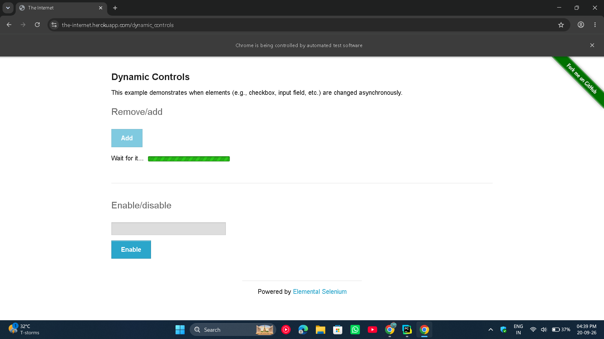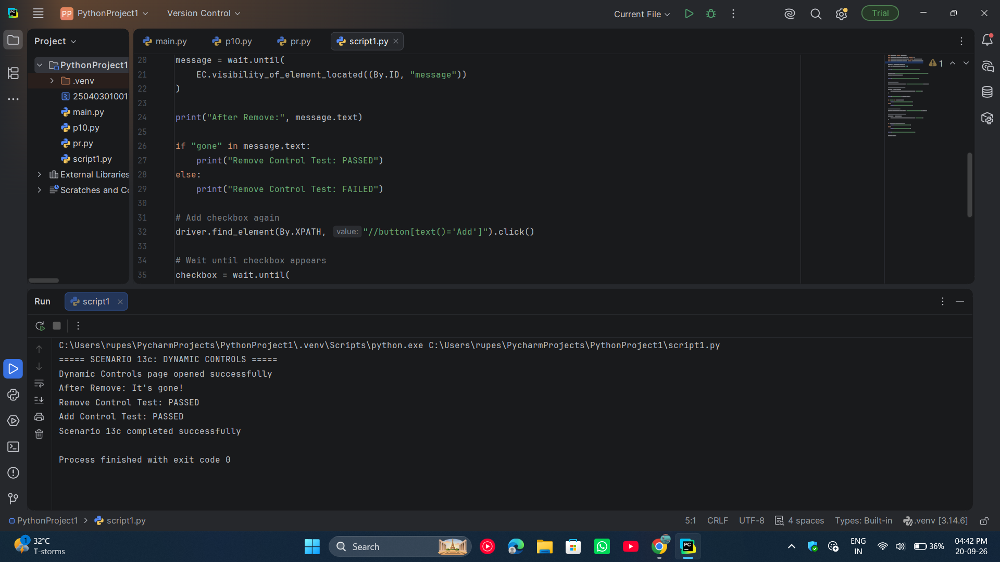

● Scenario ID: 13d
Scenario: File Upload
Test Steps:
- Open PyCharm IDE.
- Open the existing WelcomeScreen project.
- Open the script1.py file.
- Create a text file named testfile.txt in the project folder.
- Enter sample text in testfile.txt and save it.
- Write the Selenium WebDriver code in script1.py.
- Save the Python program.
- Run the program using the Run button in PyCharm.
- Selenium opens Chrome and navigates to the File Upload page.
- Selenium selects testfile.txt automatically.
- Selenium clicks the Upload button.
- Verify that the uploaded filename is displayed on the webpage.
- Verify the test result in the PyCharm console.
- Close the browser after completing the test.

Screenshots:

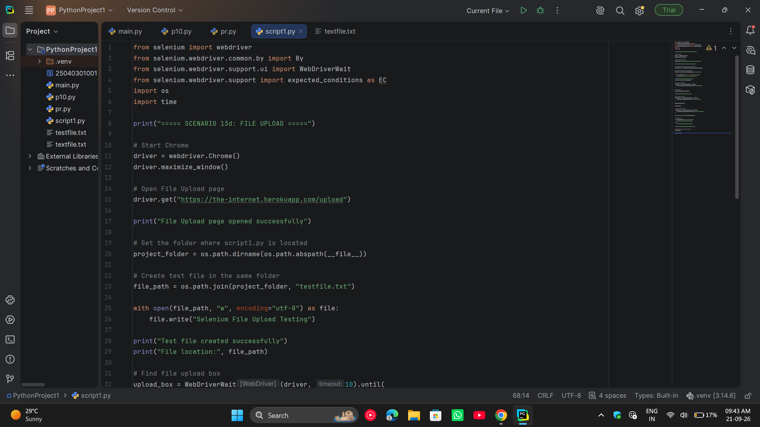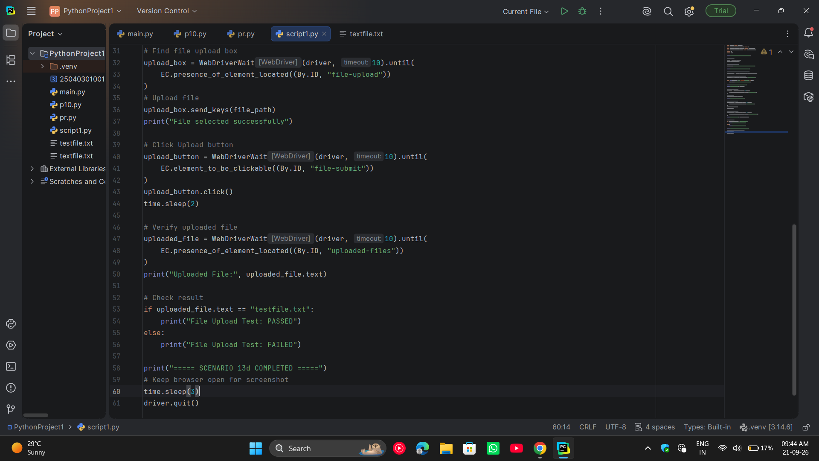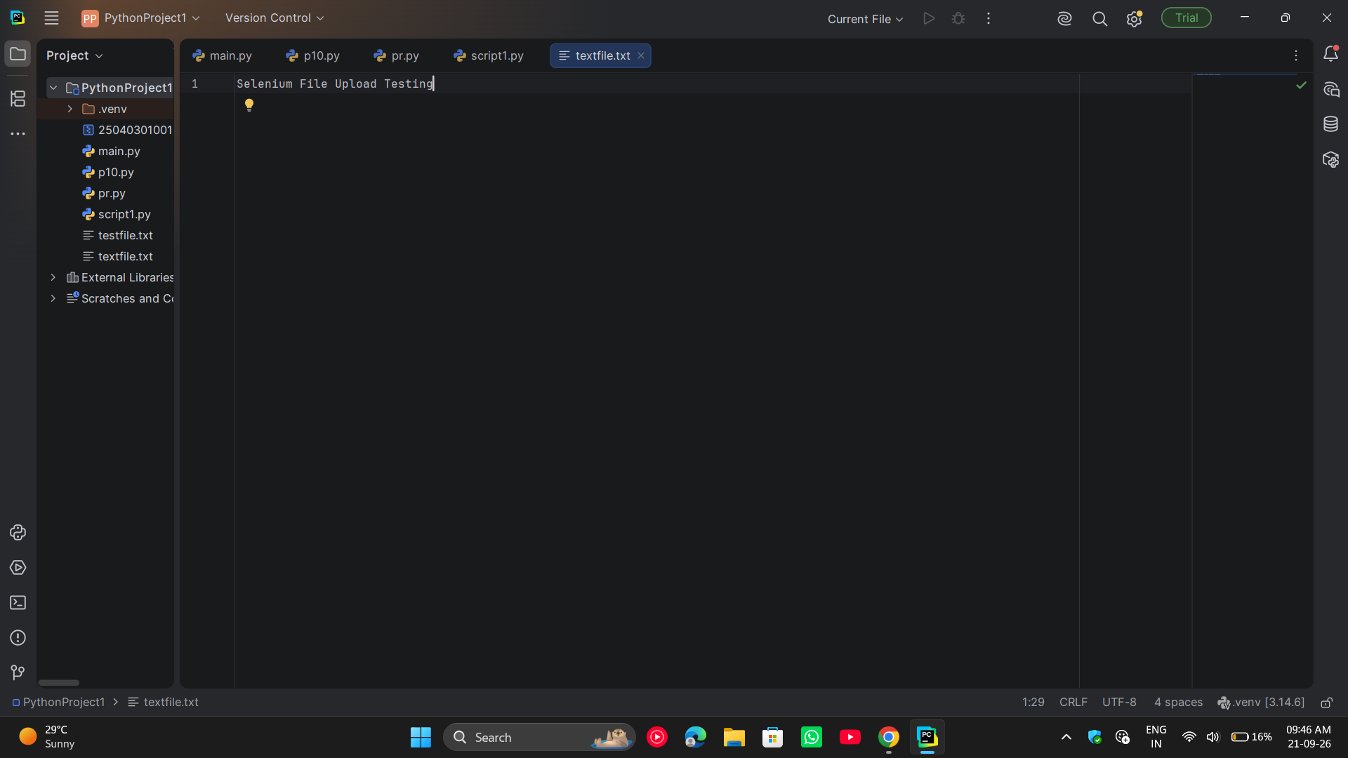
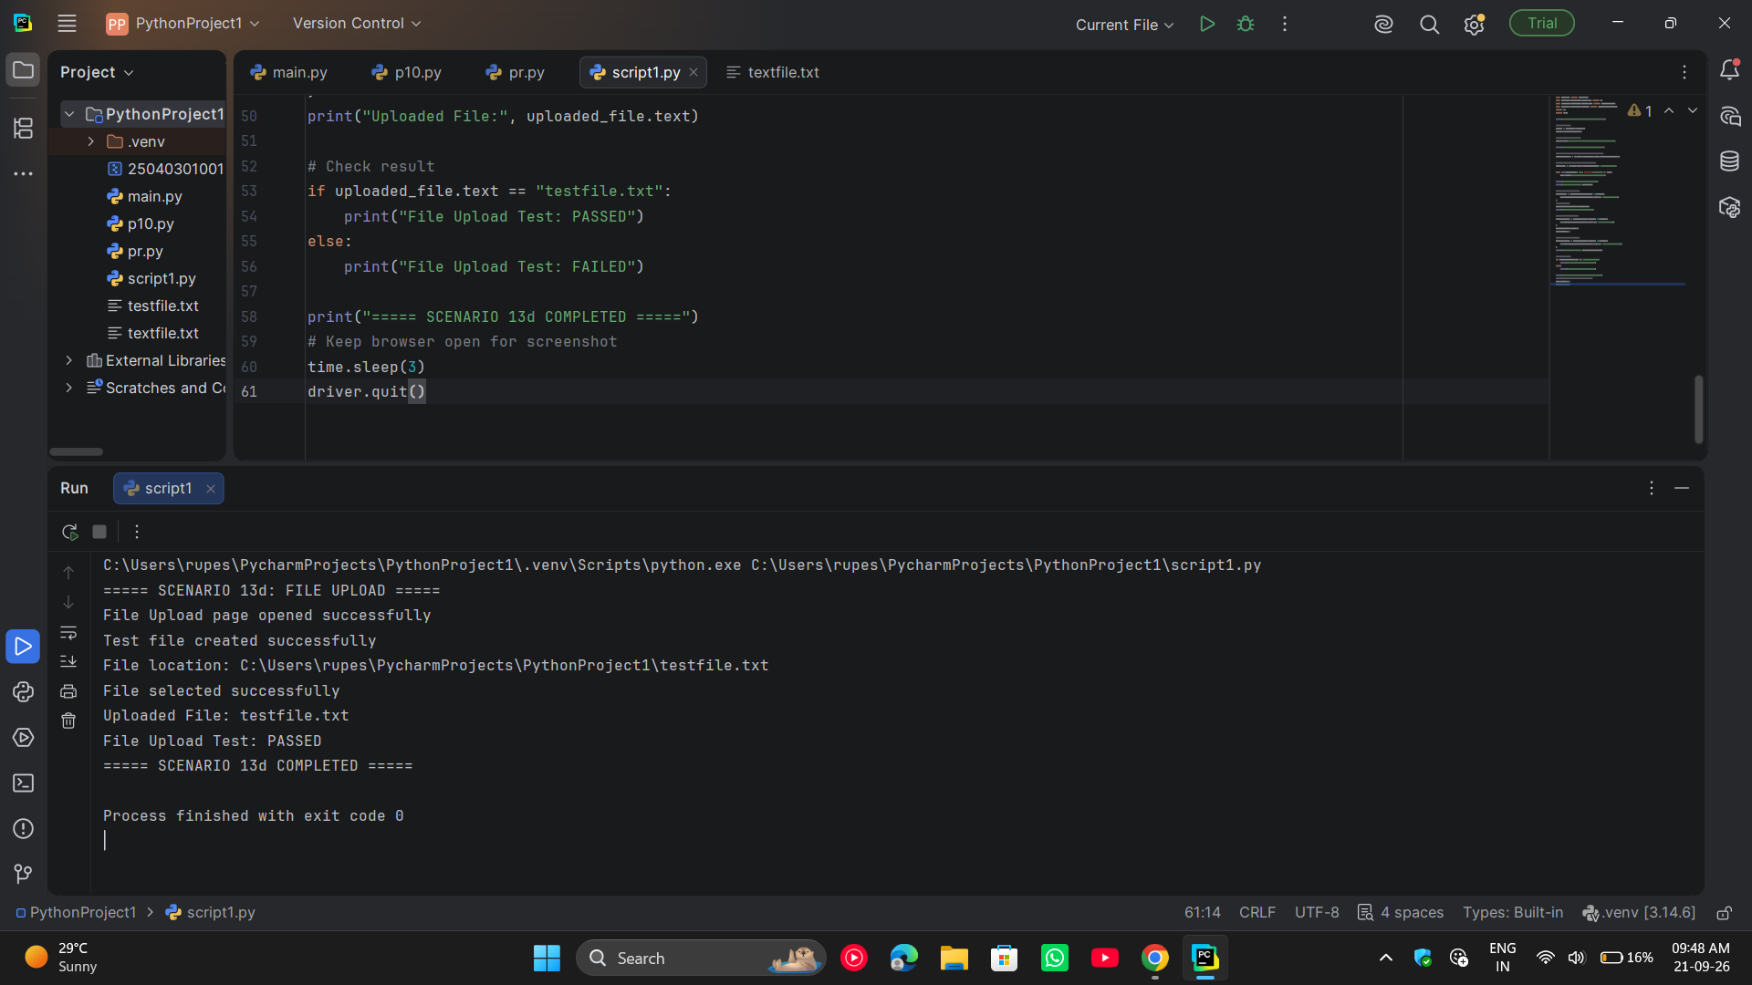

● Scenario ID: 13e
Scenario: Key Presses
Test Steps:
- Open PyCharm.
- Open the existing project.
- Open script1.py.
- Enter the Selenium automation code.
- Save the Python file.
- Run the program.
- Open the Key Presses webpage.
- Locate the webpage body.
- Press the A key using Selenium.
- Verify that “You entered: A” is displayed.
- Check the test result in the PyCharm console.
Screenshots: